**CURRICULUM VITAE**

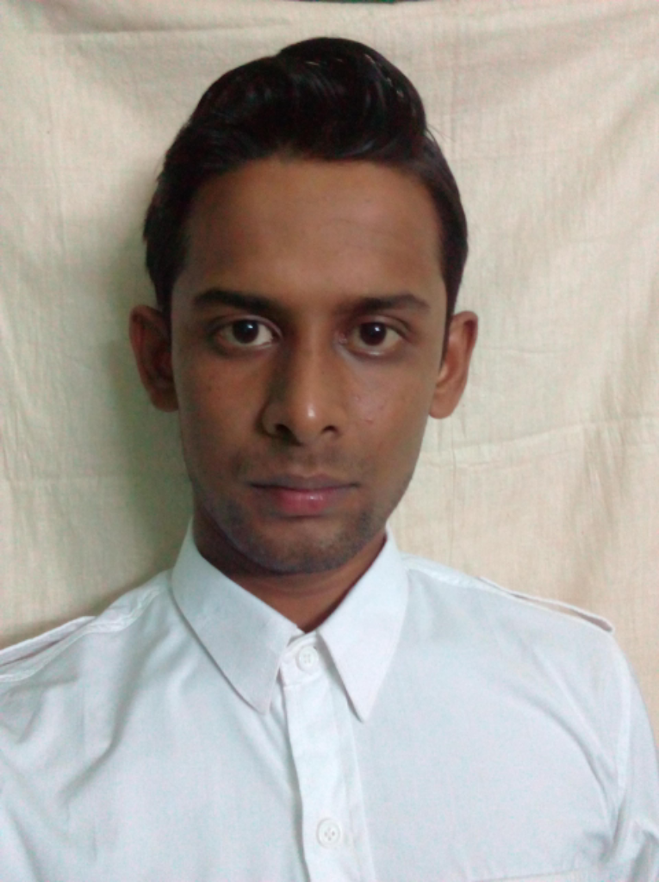

* **CONTACT INFORMATION**

1. Full Name:- **Anindya Bhowmick**
2. Current Address:-
   * 1. Vill+P.O+P.S:- jangipara
     2. Dist:- Hooghly
     3. Pin:-712404;
3. Ph No.:- **7797574067**
4. Email Address:- anindyabhowmick38@gmail.com

* **CAREER OBJECTIVE**

To obtain a challenging and responsible position in the organisation where my knowledge, skill and ability will be utilized.

* **EDUCATION QUALIFICATION :**

|  |  |  |  |  |
| --- | --- | --- | --- | --- |
| **Board** | **(Percentage of Marks)** | **Division** | **Stream** | **Year** |
| BURDWAN UNIVERSITY | 65% | 1st | BBA | 2016 |
| WBCHSE | 59% | 2nd | Science | 2013 |
| WBBSE | 65% | 1st |  | 2011 |

**\*OTBER INFORMATION:-**

I had donemy summer internship project from **SBI** Jangipara branch on '**Recovery problem of Agricultural loan'.**

**\* WORK EXPERIENCE:-**

**ORGANISATION NAME:- THE TRANSWORLD TRAVELS.**

**DESIGNATION:-** **MARKETING AND BUSINESS DEVELOPMENT EXCUTIVE.** SINCE AUGUST, 2016.

* **Extra Qualification:**

* Certificate course on Travel and Tourism Management from Global Travel Xperts Academy
* Aussie Specialist Certification on Destination Management Programme.

* **Technical Skill**

* Computer Fundamental & O.S in the year of 2013.
* Global distribution system, Sabre and Amedeous in the year of 2016.
* **Personal Information**

1. Date Of Birth:- 30/10/1995
2. Nationality:- Indian
3. Gender:- Male
4. Marital Status:- Single
5. Language: English,Hindi, Bengali

* **Key Skills**
* To understand properly the customer preference
* Good communication skill
* To work under pressure
* Good coordination among team
* Hard working with disicipline
* Good adjusting power with new people in new environment.

* **Hobbies**
* Love to travel around the world.
* To make friends.
* Watching and PLaying

**I, do here by declare that all the above statements given by me is true and correct to the best of my knowledge.**

**Date: ……………..**

**Anindya Bhowmick**

**Signature:……………………**